Prometheus and Grafana

Challenge 1 — Install Prometheus
We will start with Prometheus and Node Exporter on one Ubuntu EC2 instance. Later, we can add SNMP Exporter, Alertmanager, and Grafana to the same lab server, provided the instance has enough resources.
Step 1: Create an EC2 instance
Open the AWS Console.
- Navigate to EC2 → Instances → Launch instances.
- Enter the instance name: prometheus-monitoring-server.
- Select Ubuntu Server 24.04 LTS, 64-bit x86.
- Choose instance type t3.small for this lab, if available and within your budget.
- Create or select an SSH key pair.
- Configure the security group as below.
Type | Port | Source
SSH | 22 | My IP
Custom TCP | 9090 | My IP
Custom TCP | 9100 | My IP
Custom TCP | 3000 | My IP
Custom TCP | 9093 | My IP
These are lab access rules; we will add ports 9090, 9100, 3000 and 9093 only as needed. Do not expose monitoring interfaces to 0.0.0.0/0. For production, use private networking, VPN, or a restricted reverse proxy with authentication.
- Launch the instance.
- Wait until the instance state is Running and both status checks pass.
- Copy its public IPv4 address.
Cost note: EC2, EBS storage, and public IPv4 usage may incur charges. Stop or terminate the instance when finished, depending on whether you need to preserve the lab.
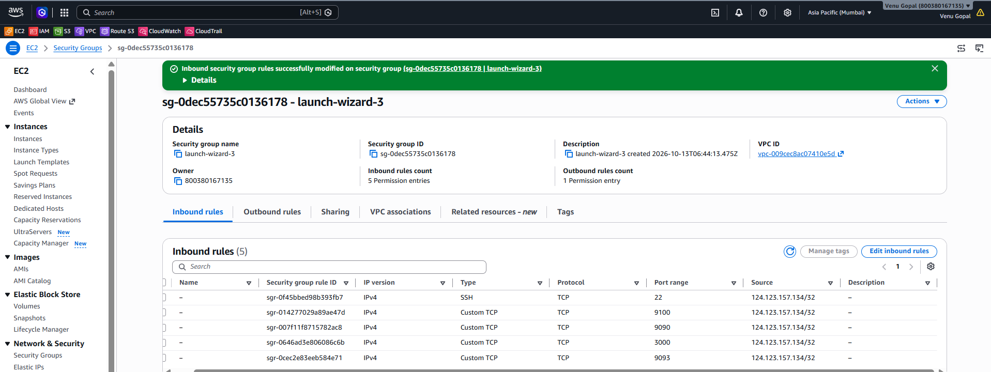
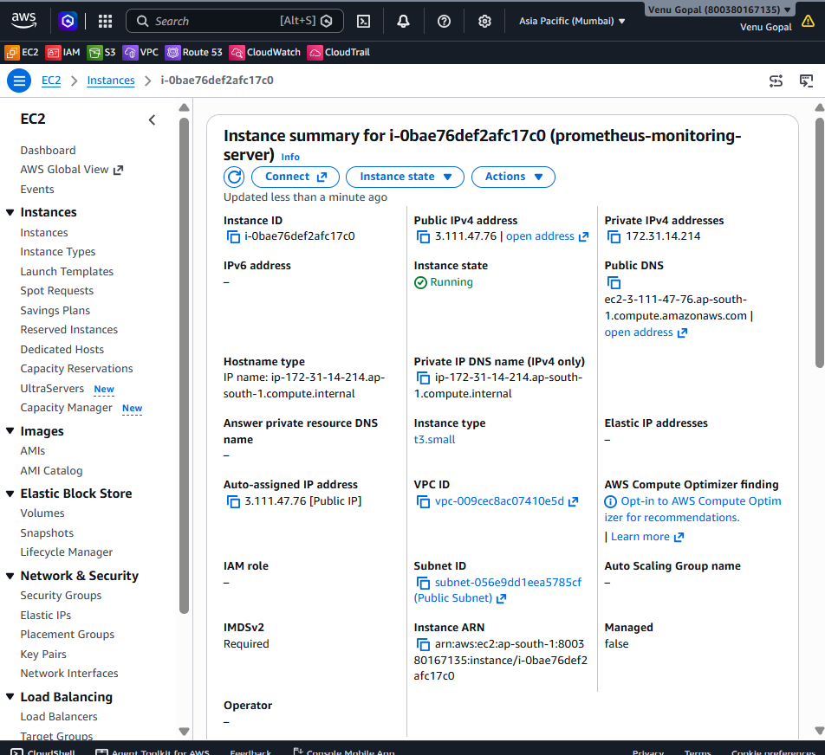
Step 2: Connect to Ubuntu
From your Windows computer, open PowerShell.
If you downloaded your key into the Downloads folder, run the following after replacing the key filename and public IP:
ssh -i "$HOME\Downloads\your-key.pem" ubuntu@YOUR_EC2_PUBLIC_IP
Replace:
- your-key.pem with your actual private key filename.
- YOUR_EC2_PUBLIC_IP with the instance's public IPv4 address.
If the connection succeeds, you should see a prompt similar to:
ubuntu@ip-172-31-xx-xx:~$
Step 3: Verify the server
Run these commands one at a time:
whoami
Expected output:
ubuntu
Next:
lsb_release -a
Confirm that the operating system is Ubuntu 24.04.
Check CPU and memory:
nproc
free -h
df -h /
These commands tell us how much CPU, RAM, and disk space are available before installing the monitoring stack.
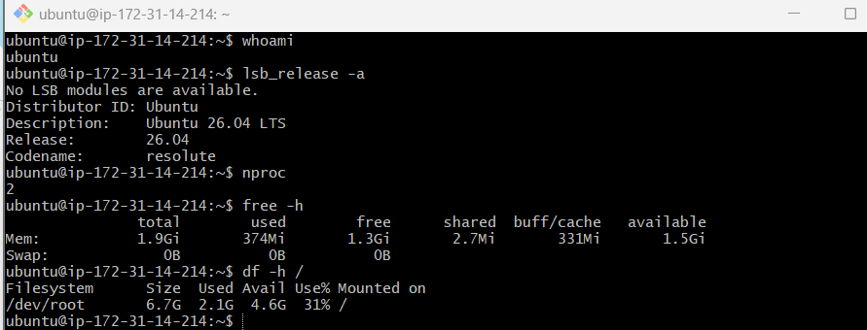
Step 4: Update Ubuntu
Run:
sudo apt update
Then:
sudo apt upgrade -y
Install the utilities we'll need:
sudo apt install -y curl wget tar gzip
Verify:
curl --version
You should see the installed curl version.
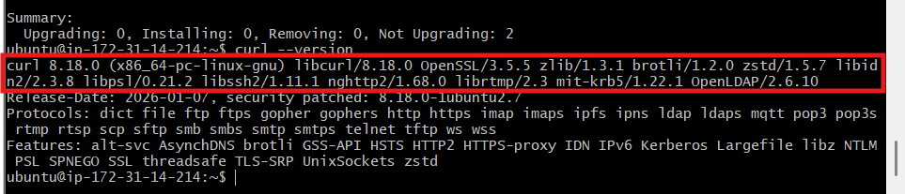
Step 5: Create a dedicated Prometheus user
Prometheus should run under a dedicated Linux account instead of root.
sudo useradd --no-create-home --shell /usr/sbin/nologin prometheus
If the user already exists, do not recreate it; verify it with:
id prometheus
Create the configuration and data directories:
sudo mkdir -p /etc/prometheus
sudo mkdir -p /var/lib/prometheus
Assign ownership:
sudo chown prometheus:prometheus /etc/prometheus
sudo chown prometheus:prometheus /var/lib/Prometheus
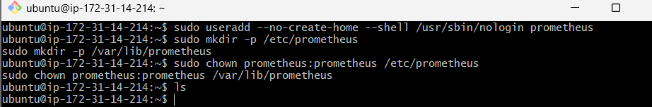
Step 6: Download Prometheus
We should use a stable release and verify the download rather than assume the newest version number.
Open the official Prometheus download page:
Official Prometheus downloads
Find the current stable Linux release for linux-amd64. Copy the version number and use it in the commands below.
cd /tmp
Set the version to the release you selected, replacing the example placeholder:
PROM_VERSION="REPLACE_WITH_VERSION"
Download and extract:
wget "https://github.com/prometheus/prometheus/releases/download/v${PROM_VERSION}/prometheus-${PROM_VERSION}.linux-amd64.tar.gz"
tar -xzf "prometheus-${PROM_VERSION}.linux-amd64.tar.gz"
Move the binaries into place:
sudo install -o root -g root -m 0755 "prometheus-${PROM_VERSION}.linux-amd64/prometheus" /usr/local/bin/prometheus
sudo install -o root -g root -m 0755 "prometheus-${PROM_VERSION}.linux-amd64/promtool" /usr/local/bin/promtool
Verify:
prometheus --version
promtool --version
Both commands should print version information. If they do not, stop here and share the error before continuing.
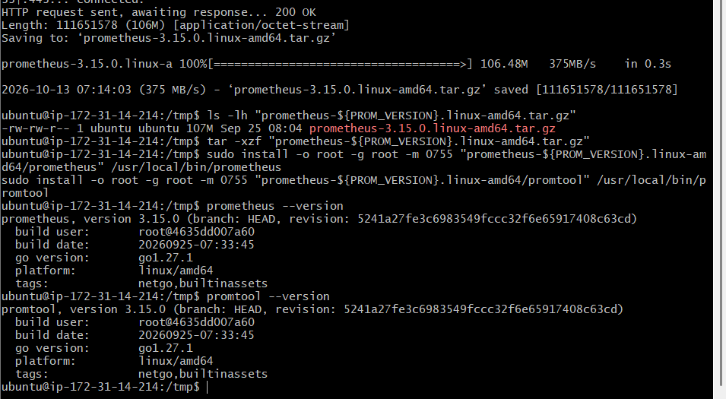
Step 7: Install the Prometheus web console files
Copy the console files from the extracted release:
cd "/tmp/prometheus-${PROM_VERSION}.linux-amd64"
sudo cp -r consoles /etc/prometheus/
sudo cp -r console_libraries /etc/prometheus/
Set ownership:
sudo chown -R prometheus:prometheus /etc/Prometheus
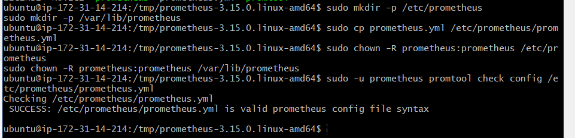
Step 8: Configure prometheus.yml
Open the configuration file:
sudo nano /etc/prometheus/prometheus.yml
Add the following configuration:

global:
scrape_interval: 15s
evaluation_interval: 15s

scrape_configs:
- job_name: "prometheus"
static_configs:
- targets: ["localhost:9090"]
Save the file in Nano:
- Press Ctrl + O.
- Press Enter.
- Press Ctrl + X.
What does this configuration mean?
- scrape_interval: 15s — Prometheus collects metrics every 15 seconds.
- evaluation_interval: 15s — Prometheus evaluates alerting rules every 15 seconds.
- job_name: prometheus — identifies the Prometheus server's own metrics job.
- localhost:9090 — tells Prometheus to monitor itself.
At this stage, we are not adding Node Exporter yet; that is Challenge 2.
Step 9: Validate the configuration
Run:
sudo -u prometheus promtool check config /etc/prometheus/prometheus.yml
Expected output should contain:
SUCCESS: /etc/prometheus/prometheus.yml is valid prometheus config file syntax
If the validation fails, fix the YAML indentation or spelling before proceeding.
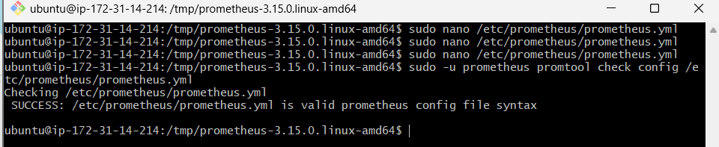
Step 10: Start Prometheus manually for the first test
Run:
sudo -u prometheus /usr/local/bin/prometheus \
--config.file=/etc/prometheus/prometheus.yml \
--storage.tsdb.path=/var/lib/prometheus
Keep this terminal open while testing. Prometheus should start and log that it is ready to receive web requests.
Open another PowerShell window on your computer and test the web endpoint:
curl.exe http://YOUR_EC2_PUBLIC_IP:9090/-/ready
Expected response:
Prometheus Server is Ready.
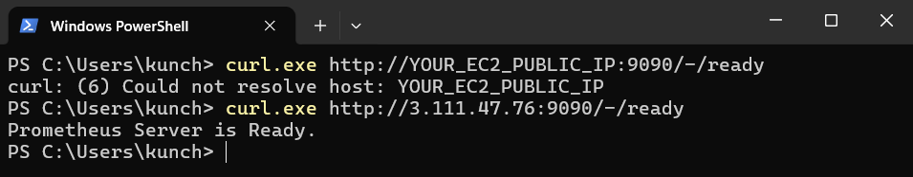
You can also open the Prometheus UI in your browser:
Prometheus getting-started documentation
For your EC2 instance, use:
http://YOUR_EC2_PUBLIC_IP:9090
If the UI does not load, check the EC2 security-group rule and the Prometheus startup logs. Do not open the port to the entire internet as a workaround.
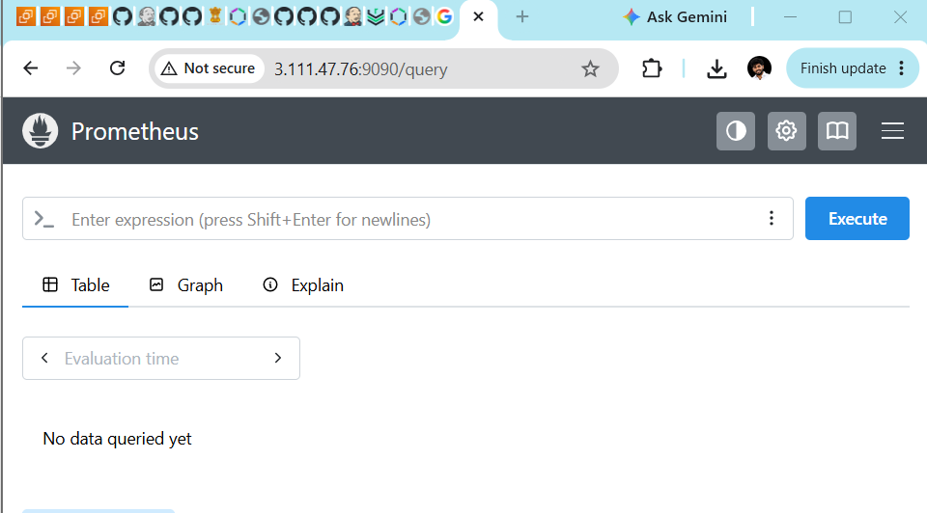
Challenge 2 — Install and Configure Node Exporter for System Monitoring.
Node Exporter collects Linux server metrics such as CPU usage, memory, disk space, and network traffic. Prometheus will scrape these metrics every 15 seconds.
Challenge 2: Node Exporter
Prometheus server
Challenge 1 — configuration prepared
Node Exporter
Challenge 2 — start here
Step 1: Open your Ubuntu terminal
Use the same EC2 server:
ubuntu@ip-172-31-14-214
Check whether Node Exporter is already installed:
node_exporter --version
If you get command not found, that's okay. We'll install it next.
Step 2: Download Node Exporter
Open the official downloads page:
Official Prometheus downloads
Find the latest stable Node Exporter Linux amd64 release.
Set the version you find on the official page. For example, replace the placeholder with the actual version:
export NODE_VERSION="REPLACE_WITH_VERSION"
Verify:
echo "$NODE_VERSION"
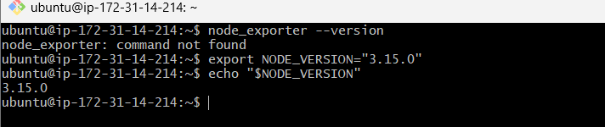
Now download the release:
cd /tmp
wget "https://github.com/prometheus/node_exporter/releases/download/v${NODE_VERSION}/node_exporter-${NODE_VERSION}.linux-amd64.tar.gz"
Step 3: Extract the archive
tar -xzf "node_exporter-${NODE_VERSION}.linux-amd64.tar.gz"
Check the extracted files:
ls -l "node_exporter-${NODE_VERSION}.linux-amd64/"
You should see the node_exporter binary.
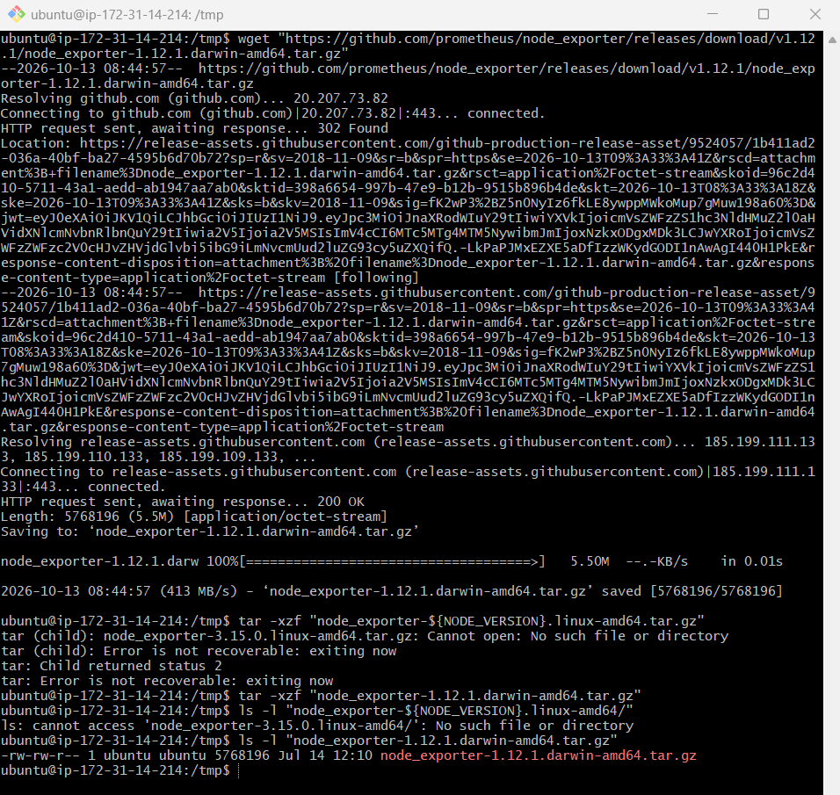
Step 5: Install Node Exporter
Run:
sudo install -o root -g root -m 0755 \
/tmp/node_exporter-1.12.1.linux-amd64/node_exporter \
/usr/local/bin/node_exporter
Verify the installation:
/usr/local/bin/node_exporter --version
You should see output showing node_exporter version 1.12.1.
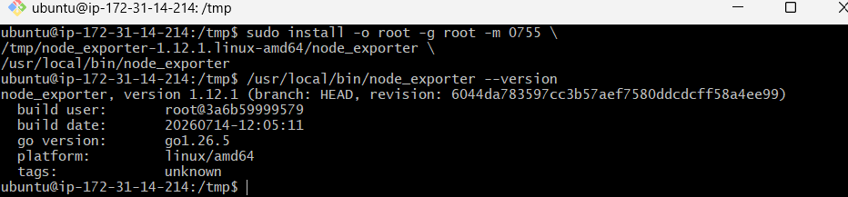
Step 6: Create the Node Exporter systemd service
Create the service file:
sudo nano /etc/systemd/system/node_exporter.service
Paste this configuration:

[Unit]
Description=Prometheus Node Exporter
Wants=network-online.target
After=network-online.target

[Service]
User=node_exporter
Group=node_exporter
Type=simple
ExecStart=/usr/local/bin/node_exporter

[Install]
WantedBy=multi-user.target
Save and exit Nano:
- Ctrl + O
- Press Enter
- Ctrl + X
You already created the node_exporter user earlier, so don't create it again.
Step 7: Start the service
Run:
sudo systemctl daemon-reload
sudo systemctl enable --now node_exporter
Check the status:
sudo systemctl status node_exporter --no-pager
Expected:
Active: active (running)
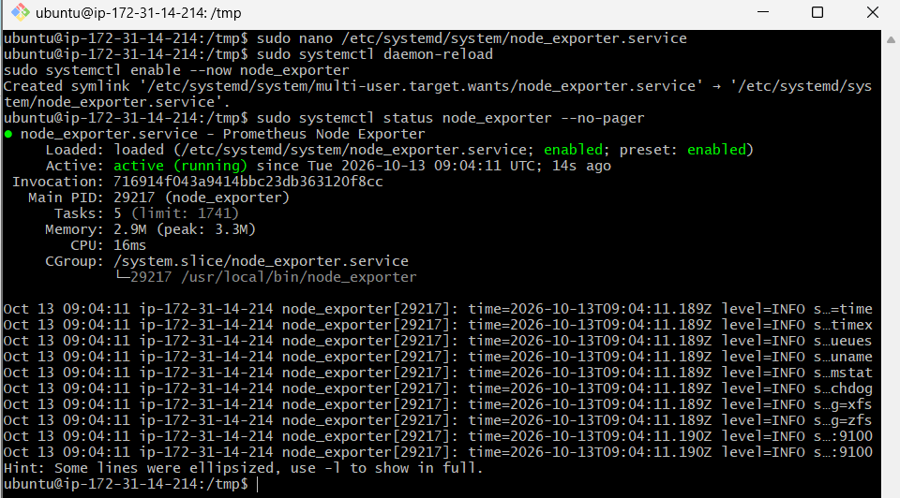
Step 8: Test system metrics
Run:
curl http://localhost:9100/metrics
You should see many metrics. To check specific ones:
curl -s http://localhost:9100/metrics | grep -E '^node_(cpu_seconds_total|memory_MemAvailable_bytes|filesystem_size_bytes|network_receive_bytes_total)'
These represent CPU, available memory, filesystem capacity, and network traffic.
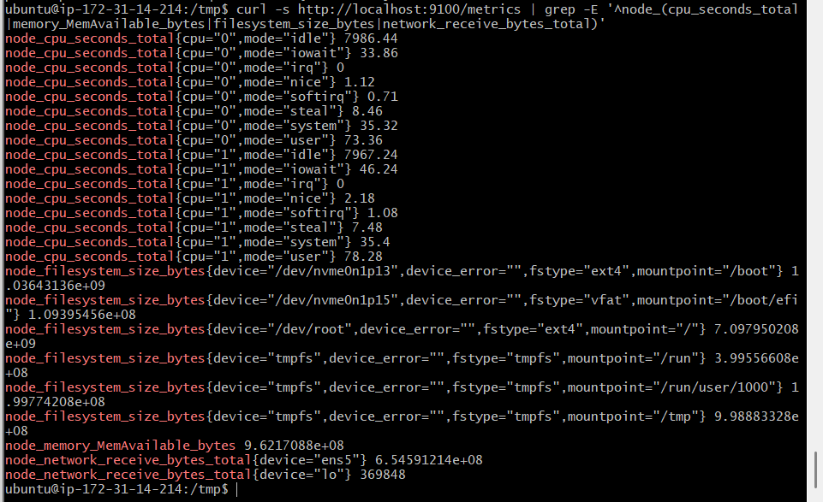
Step 9: Connect Node Exporter to Prometheus
Before editing the configuration, let's verify that your Prometheus configuration file exists:
sudo cat /etc/prometheus/prometheus.yml
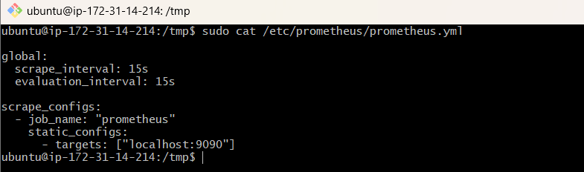
9.1 Open the configuration file
Run:
sudo nano /etc/prometheus/prometheus.yml
9.2 Update the configuration
Present configuration lo scrape_configs section undi. Existing prometheus job ni keep chesi, dani kindha node_exporter job add cheyyi.
Complete configuration ila undali:

global:
scrape_interval: 15s
evaluation_interval: 15s

scrape_configs:
- job_name: "prometheus"
static_configs:
- targets: ["localhost:9090"]

- job_name: "node_exporter"
static_configs:
- targets: ["localhost:9100"]
Important: node_exporter job, prometheus job ki same indentation level lo undali.
Save the file:
- Press Ctrl + O
- Press Enter
- Press Ctrl + X
9.3 Validate the configuration
Run:
sudo -u prometheus promtool check config /etc/prometheus/prometheus.yml
Expected output:
SUCCESS: /etc/prometheus/prometheus.yml is valid prometheus config file syntax
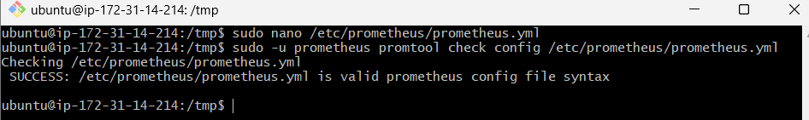
9.4 Check Node Exporter service
First, confirm it is running:
sudo systemctl status node_exporter --no-pager
Expected: Active: active (running).
If it is not running, share the error before proceeding.
9.5 Reload Prometheus configuration
If Prometheus is already running as a systemd service, use:
sudo systemctl restart prometheus
If you get Unit prometheus.service not found, that's okay. We haven't yet completed Challenge 4, where we'll create the systemd service. Tell me if you get that message rather than trying random commands.
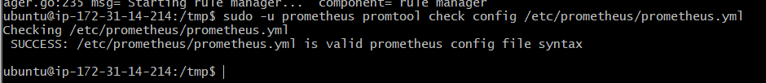
9.6 Verify both targets
Open this URL in your browser:
http://YOUR_EC2_PUBLIC_IP:9090/targets
You should eventually see:
Job | Expected state
prometheus | UP
node_exporter | UP
If Prometheus is not currently running, these targets won't appear yet. We'll start it after confirming the service setup.
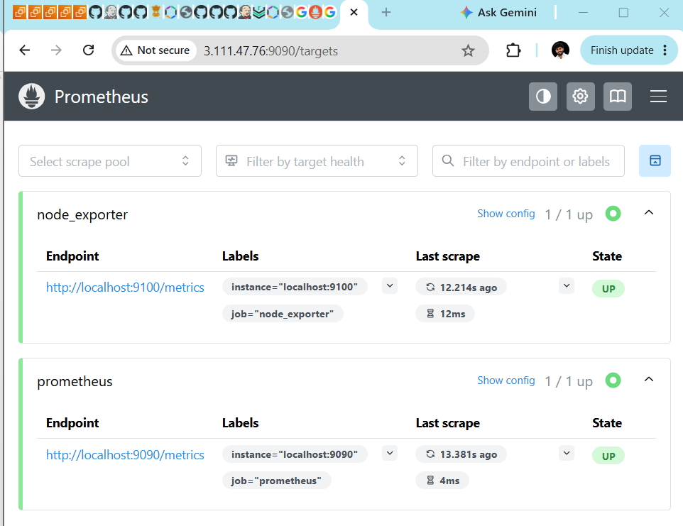

Challenge 3: Install and Configure SNMP Exporter on your existing Ubuntu EC2 monitoring server.
Challenge 3 — Step 1: Download SNMP Exporter
Official repository:
SNMP Exporter — GitHub Releases
Ee repository lo latest stable release open chesi, Assets section lo linux-amd64.tar.gz file undho choodu.
Nee terminal lo munduga:
cd /tmp
Latest version 1.12.1 Node Exporter version, SNMP Exporter version kaadu. Rendu versions different.
Step 2: Download the correct release
GitHub releases page lo kanipinche actual SNMP Exporter version ni use cheyyi:
export SNMP_VERSION="ACTUAL_VERSION"
ACTUAL_VERSION ni release page lo unna version tho replace cheyyi.
Tarvatha:
wget "https://github.com/prometheus/snmp_exporter/releases/download/v${SNMP_VERSION}/snmp_exporter-${SNMP_VERSION}.linux-amd64.tar.gz"
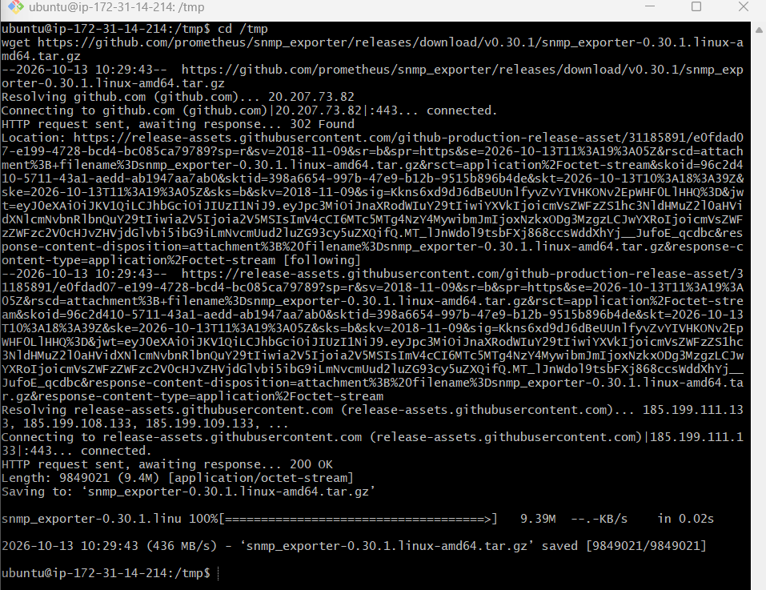
Verify:
ls -lh snmp_exporter-*.linux-amd64.tar.gz
Extract:
tar -xzf "snmp_exporter-${SNMP_VERSION}.linux-amd64.tar.gz"
Check the contents:
ls -l "/tmp/snmp_exporter-${SNMP_VERSION}.linux-amd64/"
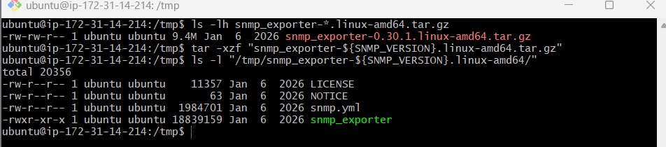
Step 3: Install SNMP Exporter
3.1 Install the binary
Run:
sudo install -o root -g root -m 0755 \
/tmp/snmp_exporter-0.30.1.linux-amd64/snmp_exporter \
/usr/local/bin/snmp_exporter
Verify:
/usr/local/bin/snmp_exporter --version
3.2 Create the configuration directory
sudo mkdir -p /etc/snmp_exporter
Copy the configuration:
sudo cp /tmp/snmp_exporter-0.30.1.linux-amd64/snmp.yml \
/etc/snmp_exporter/snmp.yml
Set permissions:
sudo chown root:root /etc/snmp_exporter
sudo chown root:root /etc/snmp_exporter/snmp.yml
sudo chmod 755 /etc/snmp_exporter
sudo chmod 644 /etc/snmp_exporter/snmp.yml
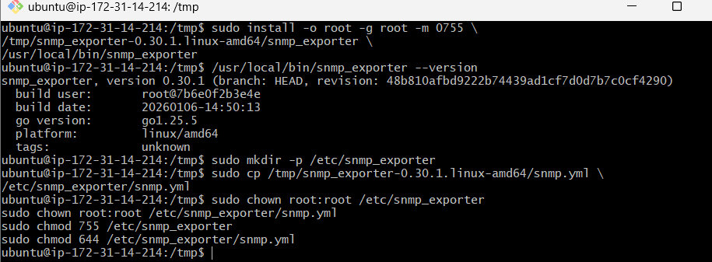
Step 4: Create the SNMP Exporter service
Create the service account if it doesn't already exist:
id snmp_exporter || sudo useradd --no-create-home --shell /usr/sbin/nologin snmp_exporter
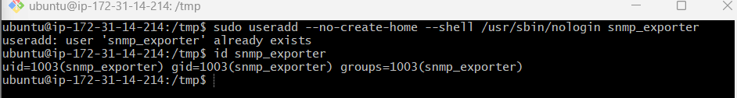
Open the service file:
sudo nano /etc/systemd/system/snmp_exporter.service
Paste this configuration:

[Unit]
Description=Prometheus SNMP Exporter
Wants=network-online.target
After=network-online.target

[Service]
User=snmp_exporter
Group=snmp_exporter
Type=simple
ExecStart=/usr/local/bin/snmp_exporter --config.file=/etc/snmp_exporter/snmp.yml --web.listen-address=:9116
Restart=on-failure

[Install]
WantedBy=multi-user.target
Save using Ctrl + O, press Enter, then Ctrl + X.
Step 5: Start SNMP Exporter
Run:
sudo systemctl daemon-reload
sudo systemctl enable --now snmp_exporter
Check status:
sudo systemctl status snmp_exporter --no-pager
Expected:
Active: active (running)
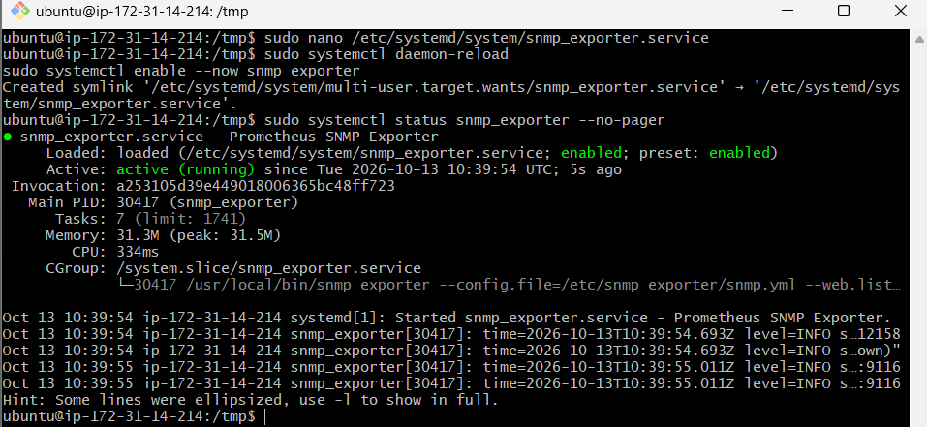
Step 6: Test the endpoint
Run:
curl -s http://localhost:9116/metrics | head
You should see exporter process metrics.
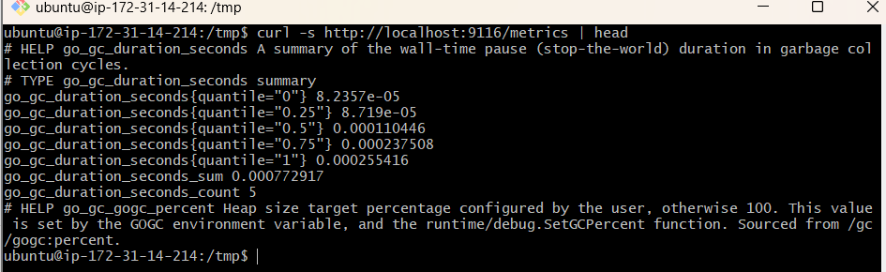
Step 7: Verify SNMP Exporter service
Run:
sudo systemctl status snmp_exporter --no-pager
Expected:
Active: active (running)
Automatic startup enable ayyindo check cheyyadaniki:
sudo systemctl is-enabled snmp_exporter
Expected:
Enabled
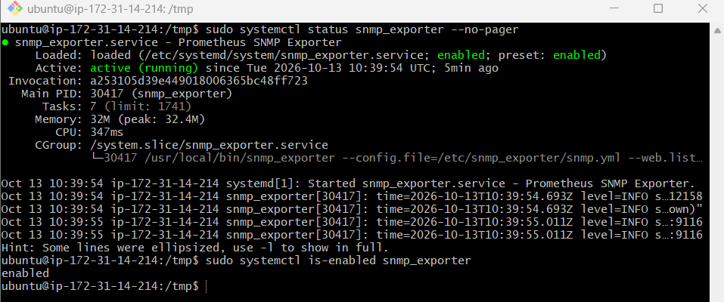
Step 8: Configure Prometheus to scrape SNMP Exporter
First, open the Prometheus configuration file:
sudo nano /etc/prometheus/prometheus.yml
Keep your existing prometheus and node_exporter jobs. Under scrape_configs:, add the following job at the same indentation level as the other jobs.

- job_name: "snmp_exporter"
static_configs:
- targets: ["localhost:9116"]
Your complete configuration should look similar to this:

global:
scrape_interval: 15s
evaluation_interval: 15s

scrape_configs:
- job_name: "prometheus"
static_configs:
- targets: ["localhost:9090"]

- job_name: "node_exporter"
static_configs:
- targets: ["localhost:9100"]

- job_name: "snmp_exporter"
static_configs:
- targets: ["localhost:9116"]
Save the file:
- Press Ctrl + O.
- Press Enter.
- Press Ctrl + X.
Important: This configuration monitors the SNMP Exporter process itself. Monitoring an actual network device requires an additional scrape job using the /snmp endpoint.
Step 9: Validate the Prometheus configuration
Run:
sudo -u prometheus promtool check config /etc/prometheus/prometheus.yml
Expected output:
SUCCESS: /etc/prometheus/prometheus.yml is valid prometheus config file syntax
If you get an error, do not restart Prometheus yet. Correct the configuration first.
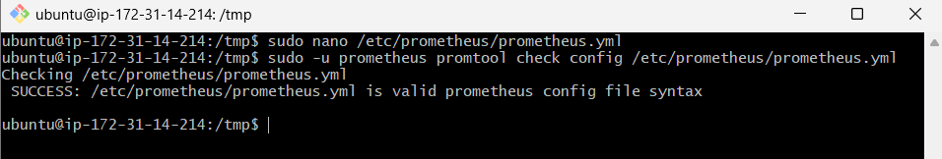
Step 10: Restart Prometheus
Run:
sudo systemctl restart prometheus
Check the service status:
sudo systemctl status prometheus --no-pager
Expected:
Active: active (running)
If the restart fails, check the logs:
sudo journalctl -u prometheus -n 50 --no-pager
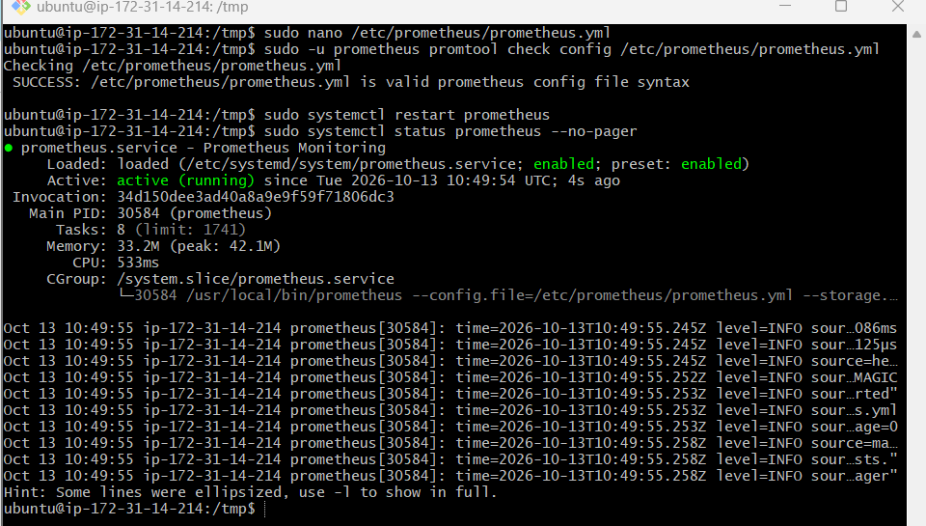
Step 11: Verify all three targets
Open the Prometheus Targets page:
Open Prometheus Targets
You should see these three jobs with the status UP:
Job | Endpoint
prometheus | localhost:9090
node_exporter | localhost:9100
snmp_exporter | localhost:9116
Allow about 15–30 seconds for the next scrape.
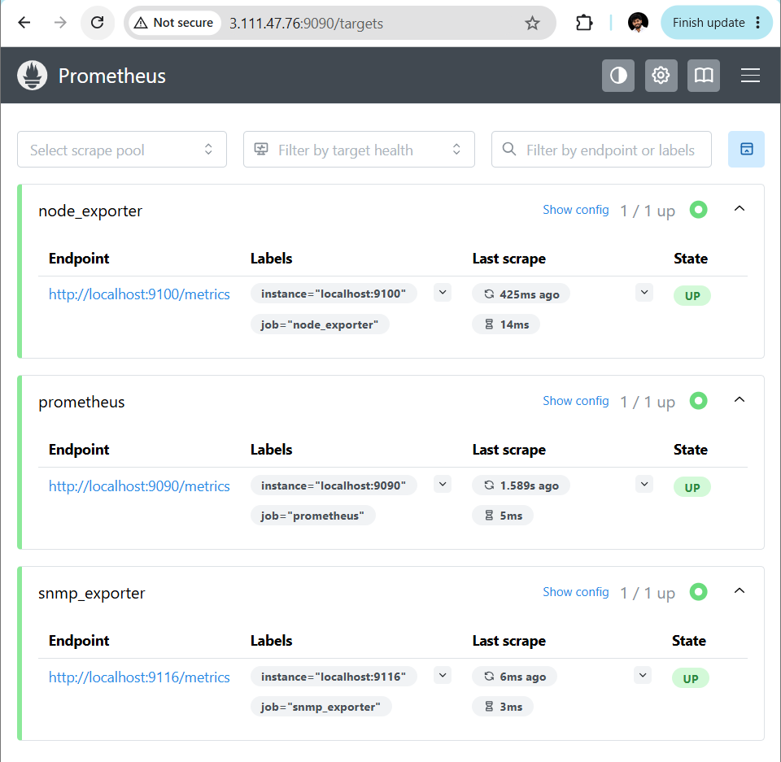
Step 12: Verify metrics in Prometheus
Open the Prometheus query page:
Open Prometheus Graph
Enter this query:
up
Click Execute. You should see a value of 1 for each healthy target.
You can also test exporter metrics with:
process_cpu_seconds_total{job="snmp_exporter"}
If the query returns data, Prometheus is collecting metrics from the exporter.
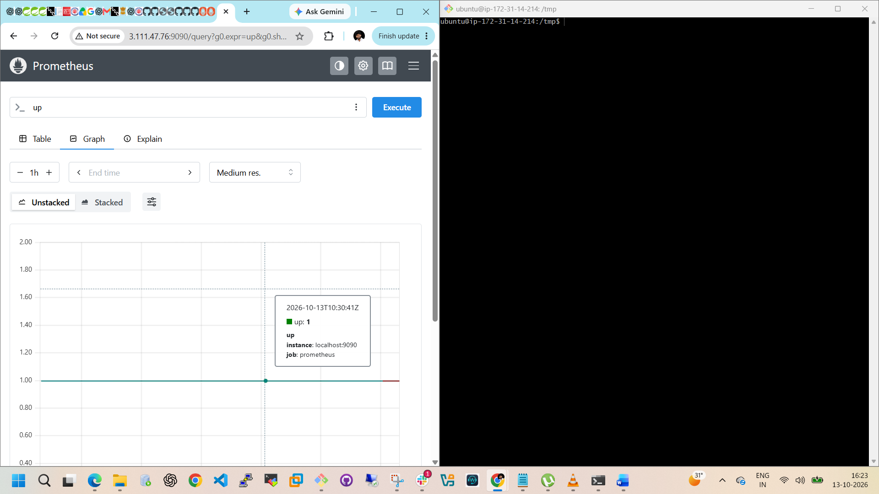
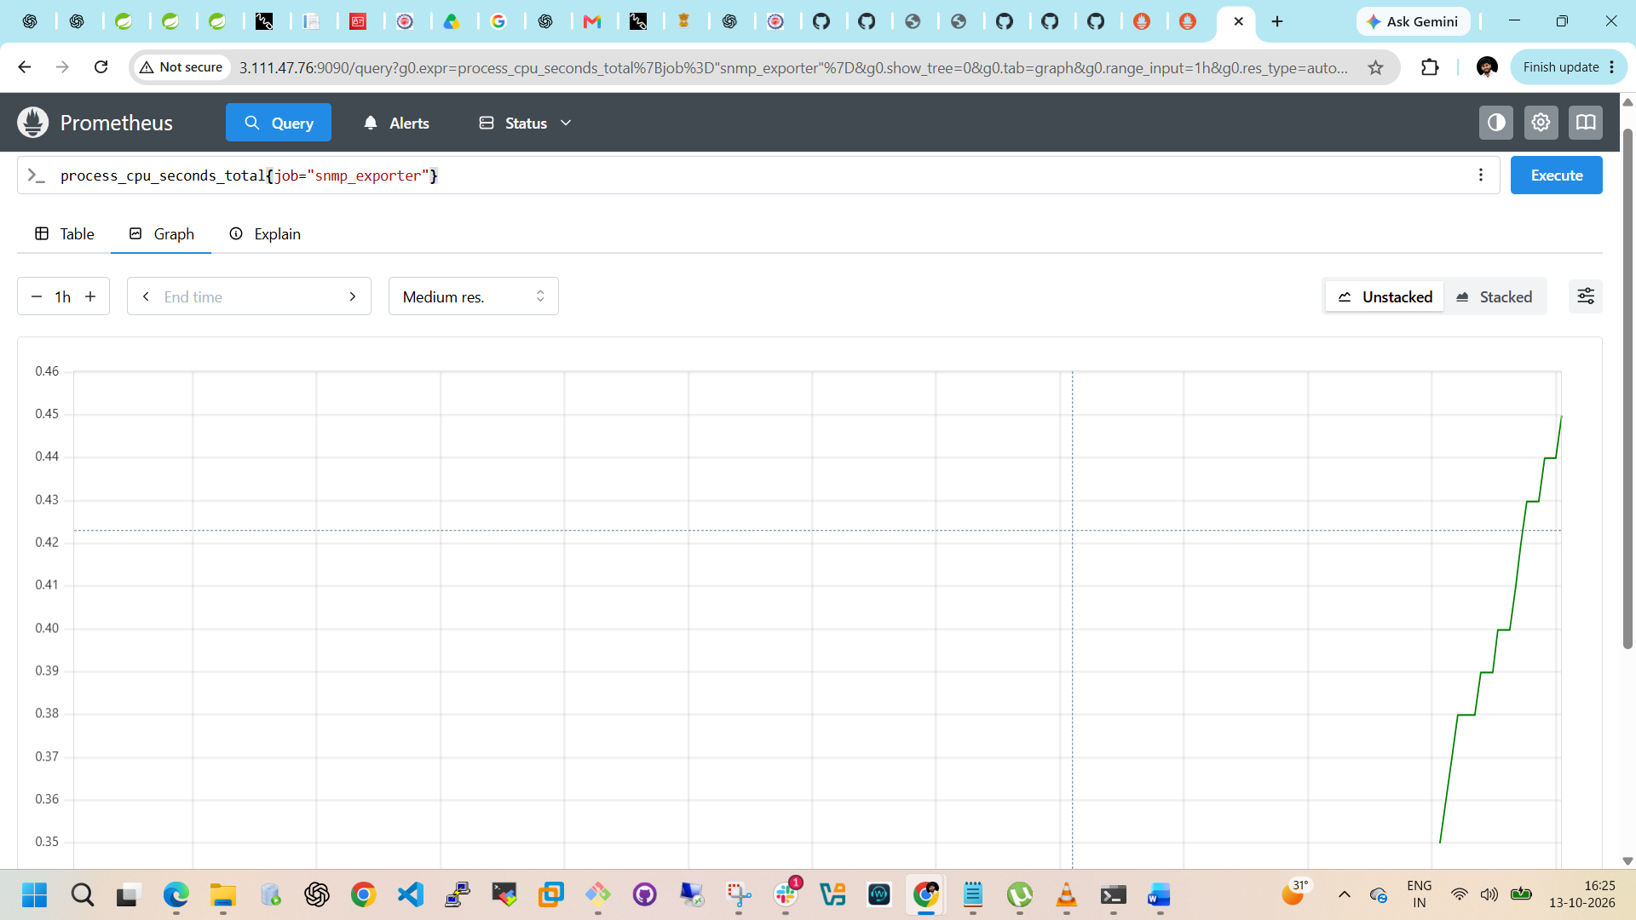
Challenge 4: Configure Prometheus as a systemd service for automatic startup. Only the required steps.
Since we already created the service earlier, first verify it rather than recreating it.
Step 1: Check Prometheus service
Run:
sudo systemctl status prometheus --no-pager
Expected: Active: active (running).
Step 2: Enable automatic startup
Run:
sudo systemctl enable prometheus
Expected output should indicate that the service is enabled.
Step 3: Verify automatic startup
Run:
sudo systemctl is-enabled prometheus
Expected:
Enabled
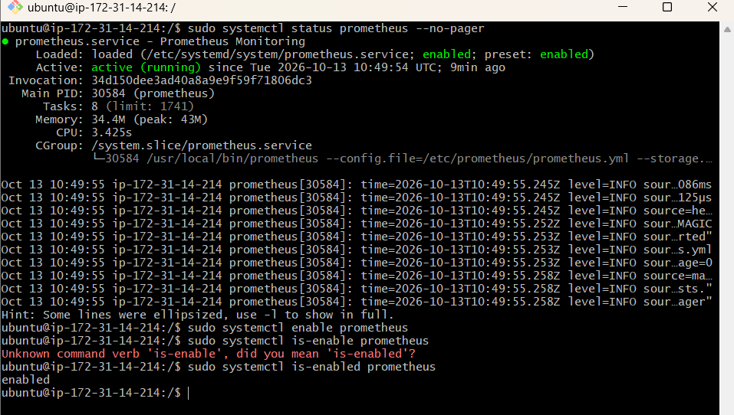
Step 4: Verify the service configuration
Run:
sudo systemctl cat prometheus
Confirm the service includes the correct configuration file:
--config.file=/etc/prometheus/prometheus.yml
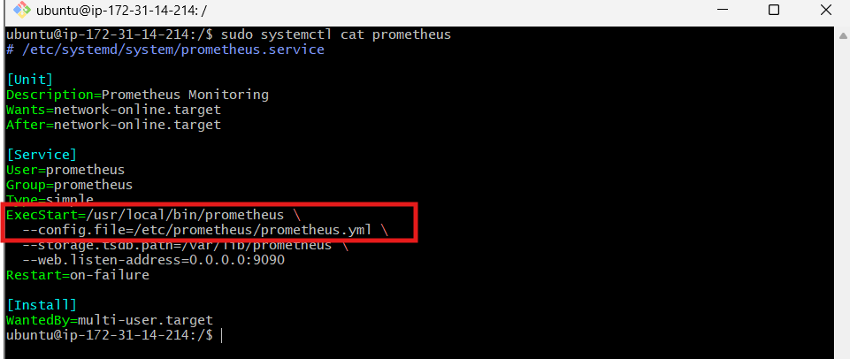
Step 5: Test restarting the service
Run:
sudo systemctl restart prometheus
sudo systemctl is-active prometheus
Expected:
active
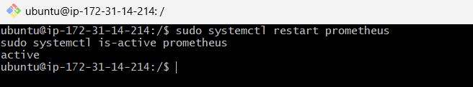

Challenge 5: Install Alertmanager and Configure Email Alerts.
Step 1: Download Alertmanager
We'll use version 0.34.1 from the release list you shared.
cd /tmp
export AM_VERSION="0.34.1"
wget "https://github.com/prometheus/alertmanager/releases/download/v${AM_VERSION}/alertmanager-${AM_VERSION}.linux-amd64.tar.gz"
Extract:
tar -xzf alertmanager-${AM_VERSION}.linux-amd64.tar.gz
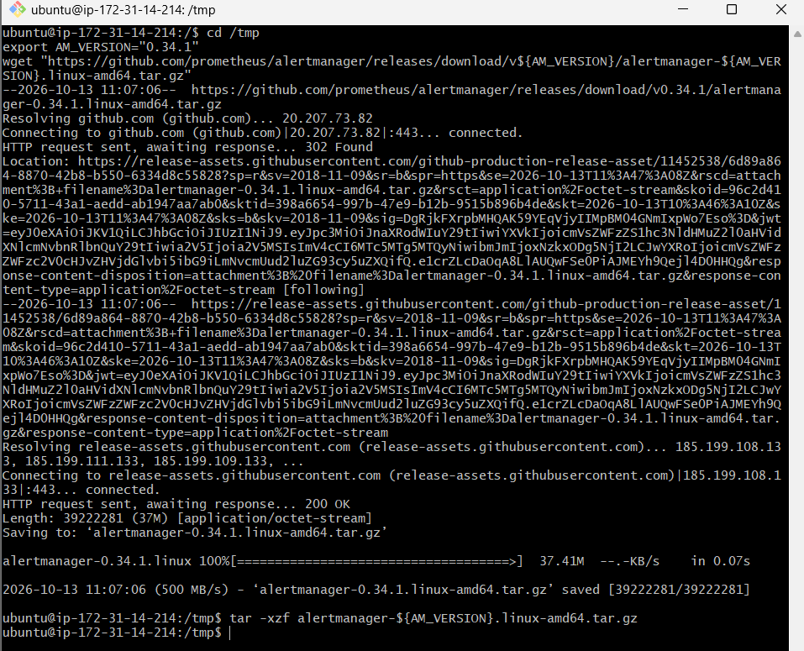
Step 2: Install Alertmanager
sudo install -o root -g root -m 0755 \
/tmp/alertmanager-${AM_VERSION}.linux-amd64/alertmanager \
/usr/local/bin/alertmanager

sudo install -o root -g root -m 0755 \
/tmp/alertmanager-${AM_VERSION}.linux-amd64/amtool \
/usr/local/bin/amtool
Create its configuration directory and copy the default configuration:
sudo mkdir -p /etc/alertmanager
sudo cp /tmp/alertmanager-${AM_VERSION}.linux-amd64/alertmanager.yml /etc/alertmanager/alertmanager.yml
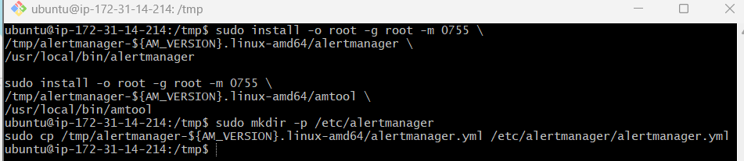
Step 3: Create the service user
sudo useradd --no-create-home --shell /usr/sbin/nologin alertmanager
If the user already exists, continue.
Set permissions:
sudo chown -R alertmanager:alertmanager /etc/alertmanager
Step 4: Configure email alerts
You need SMTP details from your email provider. For Gmail, use an App Password, not your regular Gmail password.
Open:
sudo nano /etc/alertmanager/alertmanager.yml
Replace the default configuration with this template, substituting your actual email addresses and App Password.

global:
smtp_smarthost: 'smtp.gmail.com:587'
smtp_from: 'YOUR_SENDER@gmail.com'
smtp_auth_username: 'YOUR_SENDER@gmail.com'
smtp_auth_password: 'YOUR_GMAIL_APP_PASSWORD'
smtp_require_tls: true

route:
receiver: 'email-alerts'
group_wait: 30s
group_interval: 5m
repeat_interval: 4h

receivers:
- name: 'email-alerts'
email_configs:
- to: 'YOUR_RECEIVER@gmail.com'
send_resolved: true
Save with Ctrl + O, Enter, then Ctrl + X.
Create a Gmail App Password through your Google Account security settings if you use Gmail. Do not share your password in this chat.
Restrict access to this configuration file:
sudo chmod 600 /etc/alertmanager/alertmanager.yml
sudo chown alertmanager:alertmanager /etc/alertmanager/alertmanager.yml
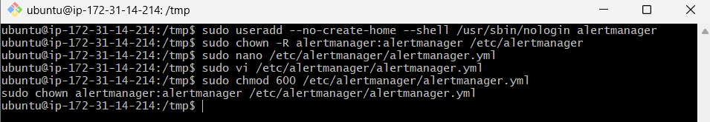
Step 5: Create the systemd service
sudo nano /etc/systemd/system/alertmanager.service
Paste:

[Unit]
Description=Prometheus Alertmanager
Wants=network-online.target
After=network-online.target

[Service]
User=alertmanager
Group=alertmanager
ExecStart=/usr/local/bin/alertmanager --config.file=/etc/alertmanager/alertmanager.yml --storage.path=/var/lib/alertmanager
Restart=on-failure

[Install]
WantedBy=multi-user.target
Save and exit. Then create the storage directory and start the service:
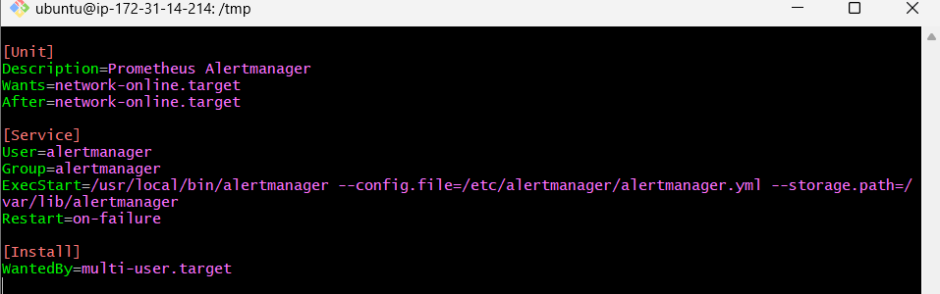
sudo mkdir -p /var/lib/alertmanager
sudo chown alertmanager:alertmanager /var/lib/alertmanager

sudo systemctl daemon-reload
sudo systemctl enable --now alertmanager
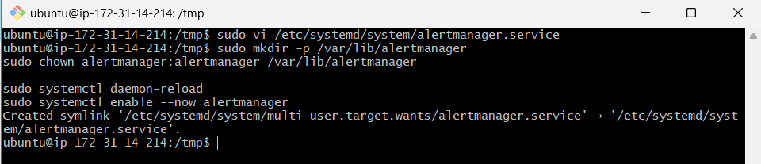
Check:
sudo systemctl status alertmanager --no-pager
Expected: Active: active (running).
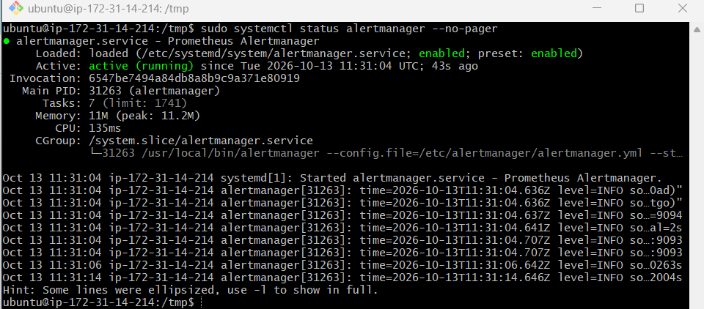
Step 6: Connect Prometheus to Alertmanager
Open:
sudo nano /etc/prometheus/prometheus.yml
Add this top-level section after the global section and before scrape_configs:
alerting:
alertmanagers:
- static_configs:
- targets: ["localhost:9093"]
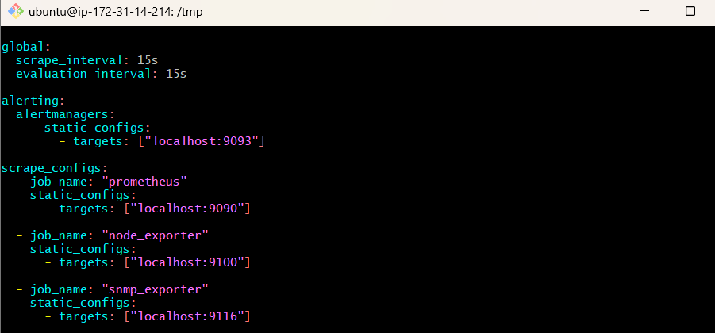
Keep all existing scrape jobs. Save the file and validate:
sudo -u prometheus promtool check config /etc/prometheus/prometheus.yml
If successful, restart Prometheus:
sudo systemctl restart Prometheus
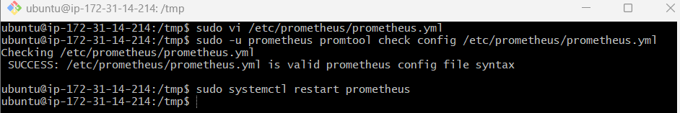
Step 7: Verify Alertmanager
sudo systemctl is-active alertmanager
curl -s http://localhost:9093/-/ready
Expected readiness response:
Ready
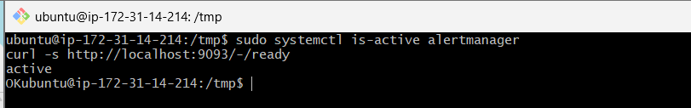
Open the UI:
Open Alertmanager UI
Keep port 9093 restricted to your IP in the EC2 security group.
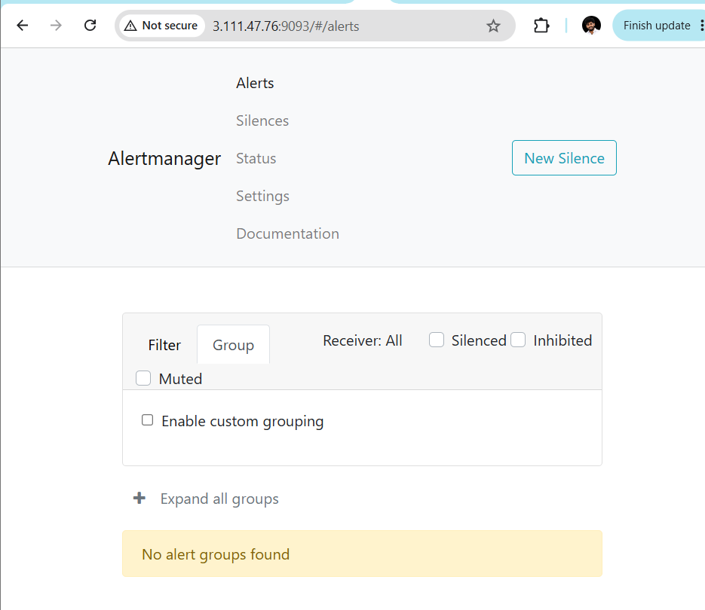

Challenge 6: Install Grafana and Add Prometheus as a Data Source.
We'll use your existing Ubuntu EC2 server (ip-172-31-14-214) where Prometheus is already running.
Step 1: Install required packages
sudo apt-get update
sudo apt-get install -y apt-transport-https wget gnupg
Step 2: Add the official Grafana repository
Add Grafana's signing key:
sudo mkdir -p /etc/apt/keyrings
wget -q -O - https://apt.grafana.com/gpg.key | \
gpg --dearmor | sudo tee /etc/apt/keyrings/grafana.gpg > /dev/null
Add the repository:
echo "deb [signed-by=/etc/apt/keyrings/grafana.gpg] https://apt.grafana.com stable main" | \
sudo tee /etc/apt/sources.list.d/grafana.list
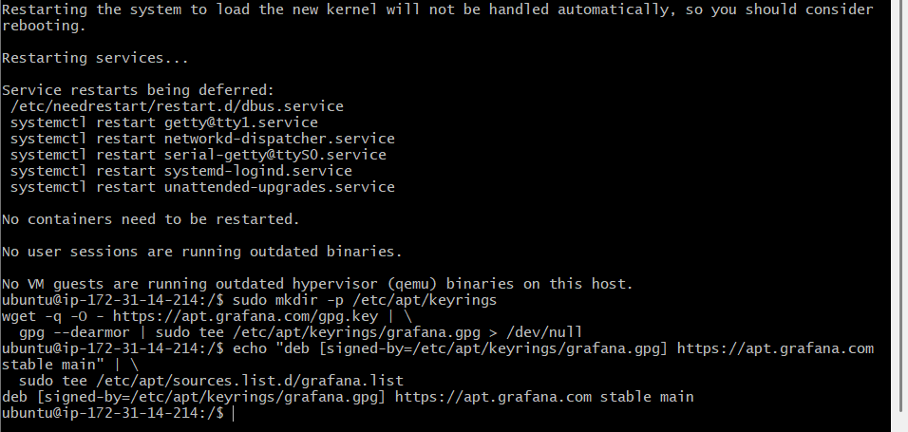
Step 3: Install Grafana
sudo apt-get update
sudo apt-get install -y grafana
Step 4: Start Grafana and enable automatic startup
sudo systemctl daemon-reload
sudo systemctl enable --now grafana-server
Verify:
sudo systemctl status grafana-server --no-pager
Expected:
Active: active (running)
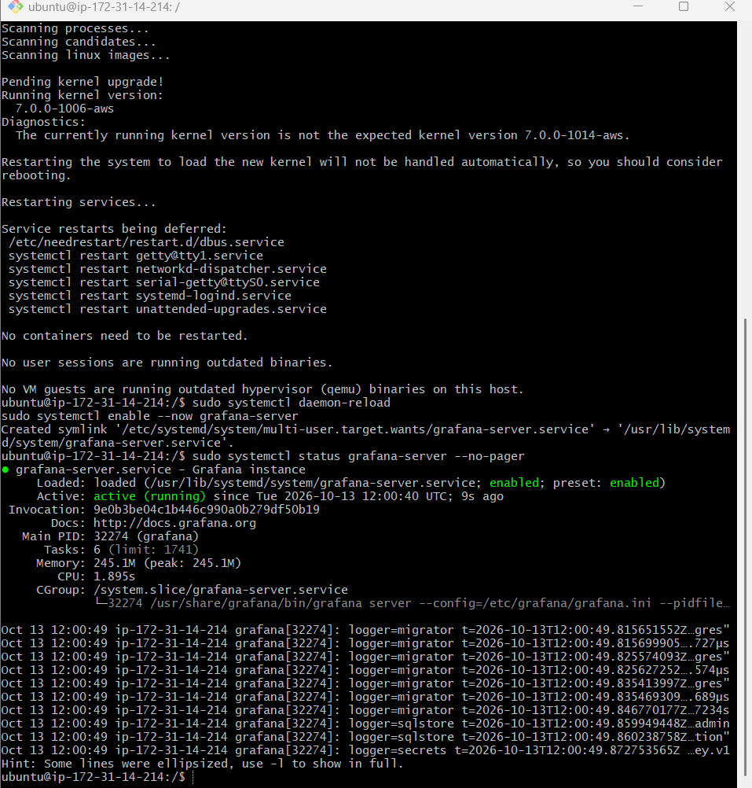
Step 5: Allow Grafana access in AWS
In the AWS EC2 console:
- Open Instances and select your monitoring EC2 instance.
- Open its Security tab.
- Click the attached security group.
- Select Edit inbound rules.
- Add a rule:
Setting | Value
Type | Custom TCP
Port | 3000
Source | My IP
Save the rule. Do not expose Grafana publicly to 0.0.0.0/0.
Step 6: Open Grafana
Open this URL in your browser:
Open Grafana
Default initial login:
- Username: admin
- Password: admin
Grafana will normally prompt you to set a new password after your first login. Choose a strong password.
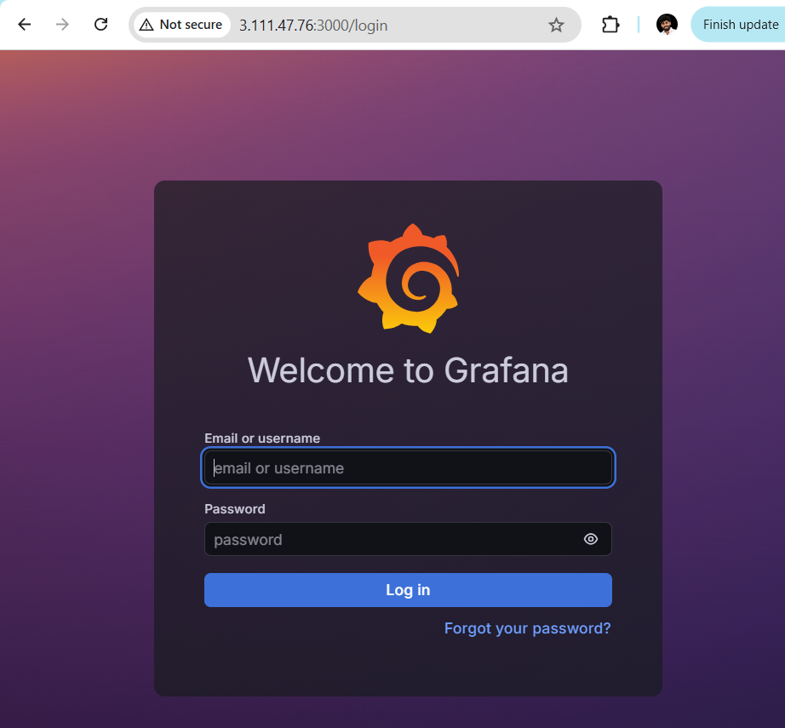
Step 7: Add Prometheus as a data source
In Grafana:
- Open Connections.
- Select Data sources.
- Click Add data source.
- Choose Prometheus.
- In the Prometheus server URL field, enter:
http://localhost:9090
- Leave other settings at their defaults for this local setup.
- Click Save & test.
Expected result: a successful data source connection.
Important: Use http://localhost:9090 because Grafana and Prometheus are running on the same EC2 server.
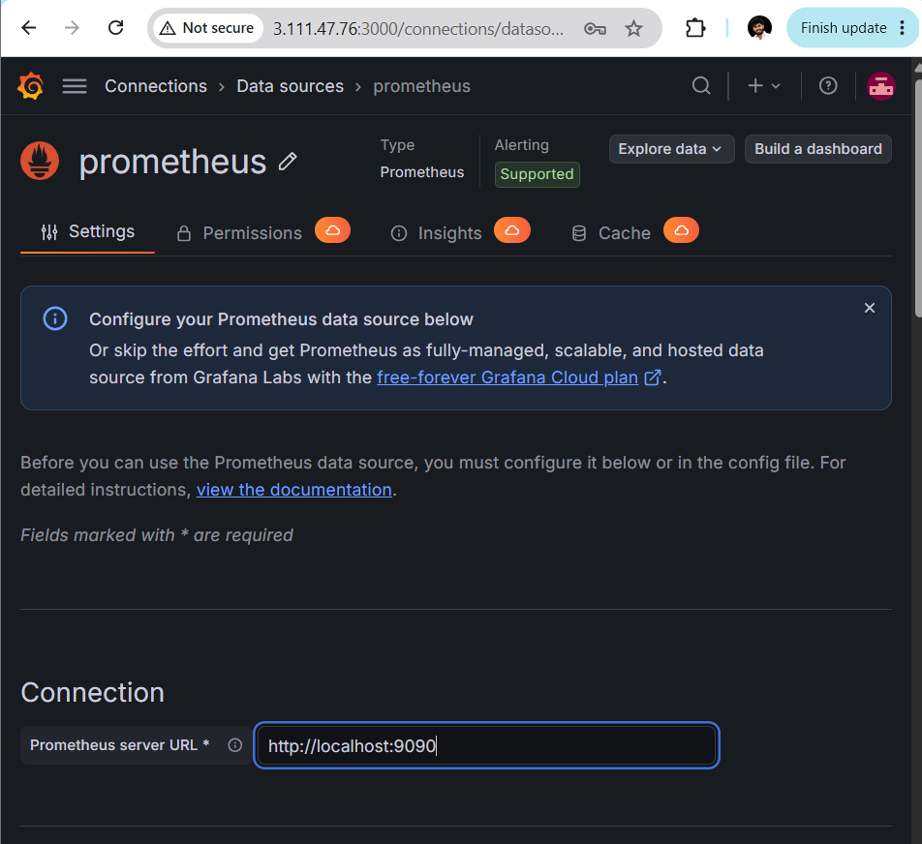
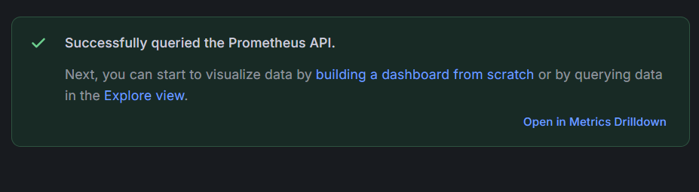
Step 8: Verify metrics in Grafana
- Open Explore in the Grafana sidebar.
- Select the Prometheus data source.
- Enter this query:
up
4. Click Run query.
You should see the Prometheus, Node Exporter, and SNMP Exporter targets with values of 1 if all are healthy.
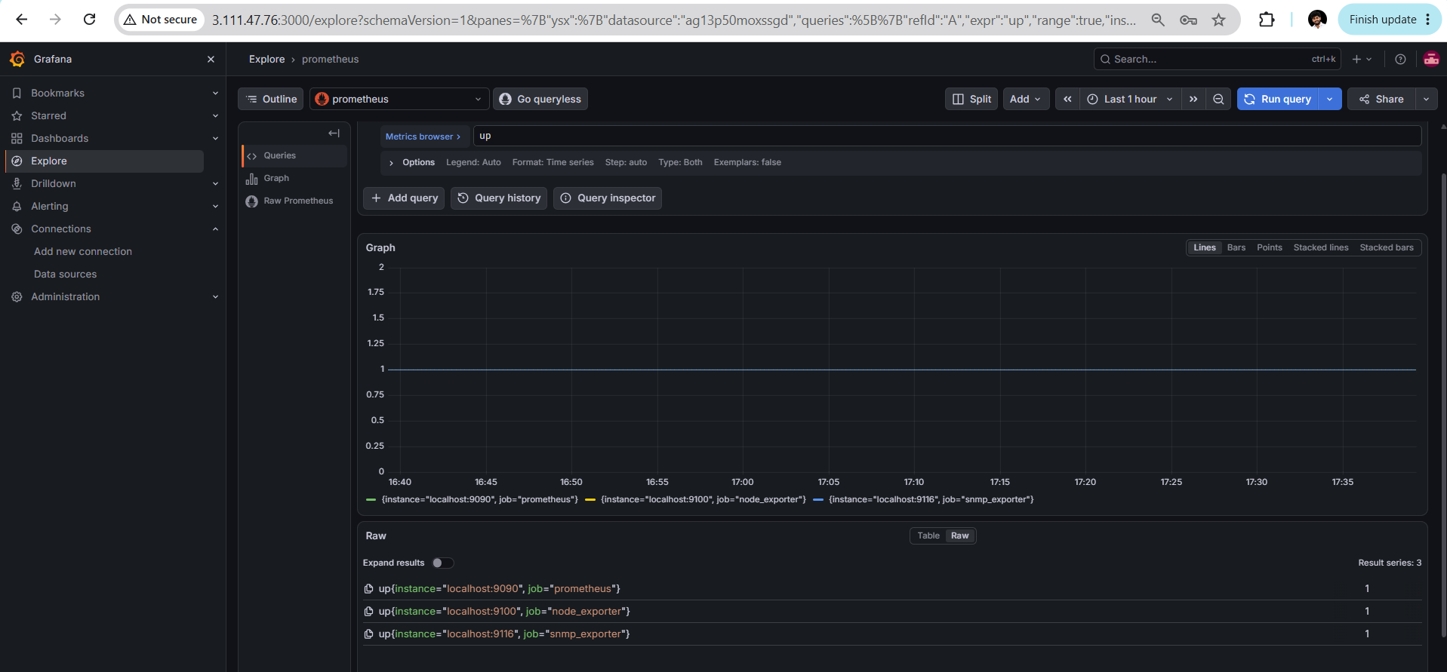

Challenge 7: Configure Prometheus for Service Discovery of Dynamic Targets. We'll use Prometheus's built-in file-based service discovery so you can add or remove monitoring targets without editing prometheus.yml each time.
Step 1: Create a directory for dynamic targets
On your Ubuntu EC2 server, run:
sudo mkdir -p /etc/prometheus/file_sd
sudo chown -R prometheus:prometheus /etc/prometheus/file_sd
Step 2: Create the targets file
sudo nano /etc/prometheus/file_sd/targets.json
Add this JSON configuration:
[
{
"targets": ["localhost:9100"],
"labels": {
"env": "dev",
"service": "node-exporter"
}
}
]
Save with Ctrl+O, press Enter, then Ctrl+X.
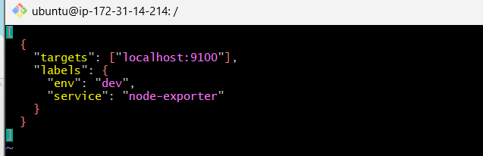
Step 3: Update prometheus.yml
Open the file:
sudo nano /etc/prometheus/prometheus.yml
Under the existing scrape_configs: section, add this new job. Keep your existing jobs for Prometheus, Node Exporter, and SNMP Exporter.
- job_name: "dynamic_targets"
file_sd_configs:
- files:
- "/etc/prometheus/file_sd/targets.json"
refresh_interval: 30s
Make sure the new job is indented at the same level as your other - job_name entries.
Step 4: Validate the configuration
sudo promtool check config /etc/prometheus/prometheus.yml
Expected output:
SUCCESS: /etc/prometheus/prometheus.yml is valid
If promtool is not in your PATH, run:
/usr/local/bin/promtool check config /etc/prometheus/prometheus.yml
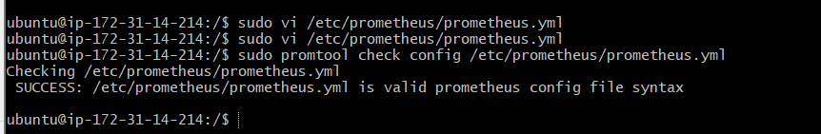
Step 5: Reload Prometheus
Restart the service:
sudo systemctl restart prometheus
Verify:
sudo systemctl is-active prometheus
Expected: active.
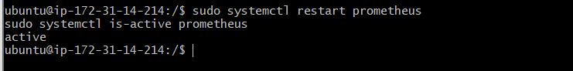
Step 6: Verify the dynamic target
Open the Targets page:
Open Prometheus Targets
Find dynamic_targets. It should show localhost:9100 as UP.
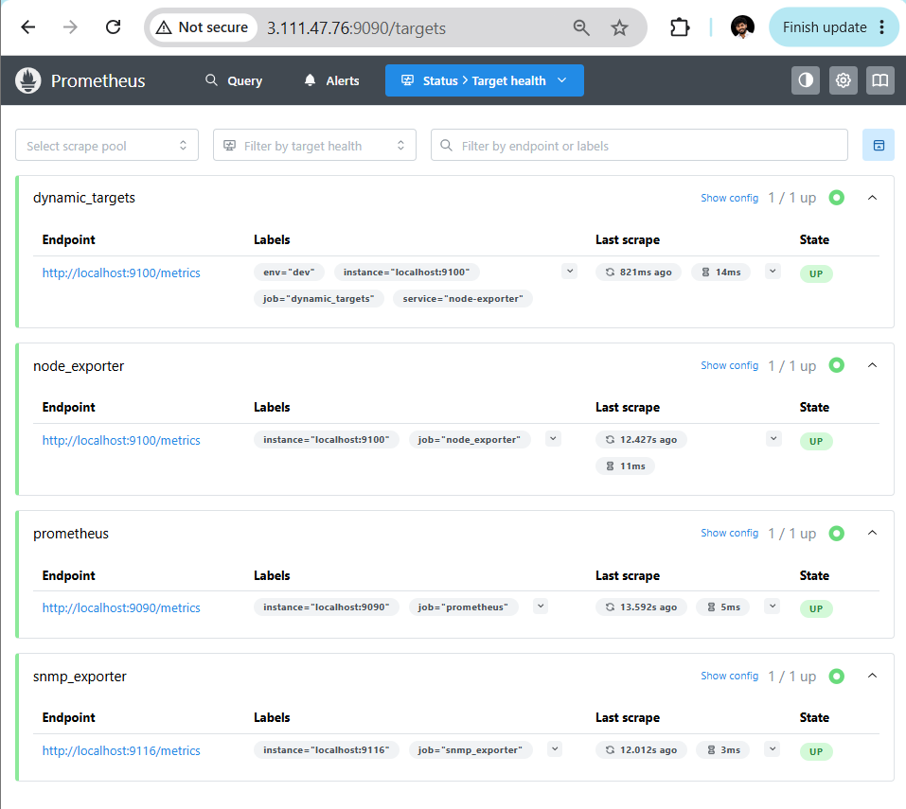
Step 7: Test dynamic discovery
Add another target to targets.json:
[
{
"targets": ["localhost:9100"],
"labels": {
"env": "dev",
"service": "node-exporter"
}
},
{
"targets": ["localhost:9090"],
"labels": {
"env": "dev",
"service": "prometheus-test"
}
}
]
Save the file. Wait 30 seconds and refresh the Targets page. Both targets should appear under dynamic_targets without restarting Prometheus.
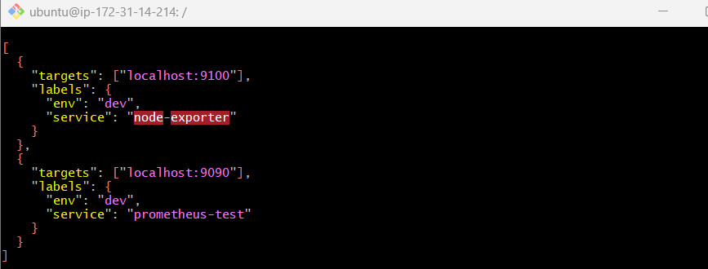
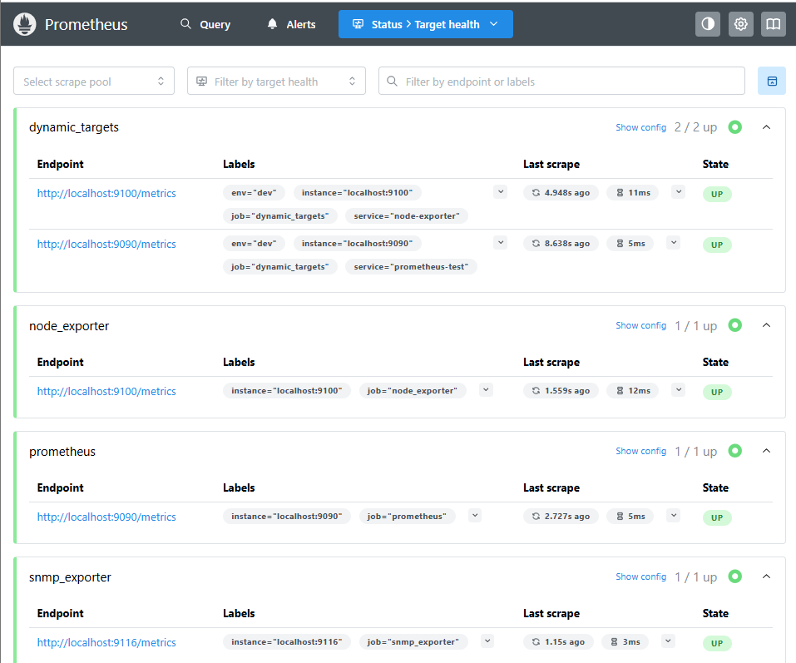

Challenge 8 — Create a disk-space alerting rule
Step 1: Create the rules file
sudo nano /etc/prometheus/first_rules.yml
Paste:
groups:
- name: disk_space_alerts
rules:
- alert: DiskSpaceLow
expr: |
(
node_filesystem_avail_bytes{mountpoint="/", fstype!~"tmpfs|overlay"}
/
node_filesystem_size_bytes{mountpoint="/", fstype!~"tmpfs|overlay"}
) * 100 < 15
for: 1m
labels:
severity: warning
annotations:
summary: "Low disk space on {{ $labels.instance }}"
description: "Less than 15% disk space remains on the root filesystem."
Save with Ctrl+O, Enter, then Ctrl+X.
Step 2: Connect the rules file to Prometheus
Open:
sudo nano /etc/prometheus/prometheus.yml
Add this top-level section, aligned with global:, alerting:, and scrape_configs::
rule_files:
- "/etc/prometheus/first_rules.yml"
Do not delete your existing configuration.
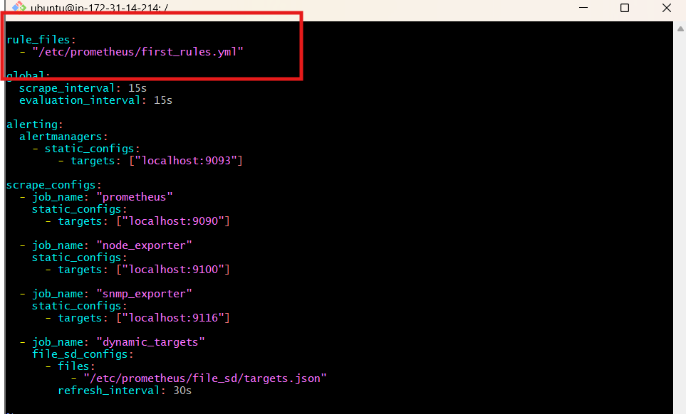
Step 3: Validate both configurations
sudo promtool check rules /etc/prometheus/first_rules.yml
sudo promtool check config /etc/prometheus/prometheus.yml
Both commands should report success.
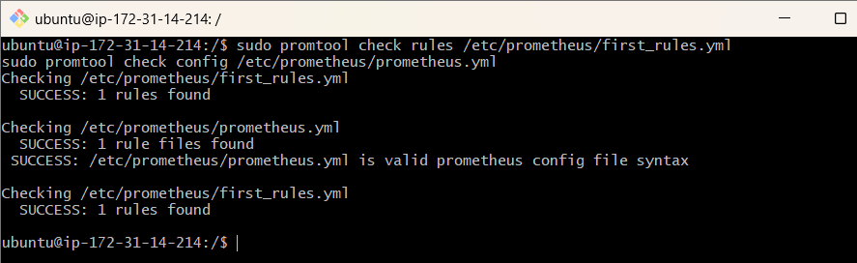
Step 4: Restart Prometheus
sudo systemctl restart prometheus
sudo systemctl is-active prometheus
Expected: active.
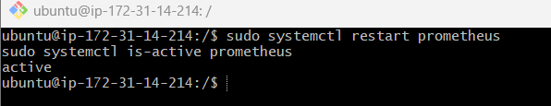
Step 5: Verify the alert rule
Open the Prometheus Alerts page.
You should see DiskSpaceLow. It will normally remain inactive while your root filesystem has at least 15% free space.
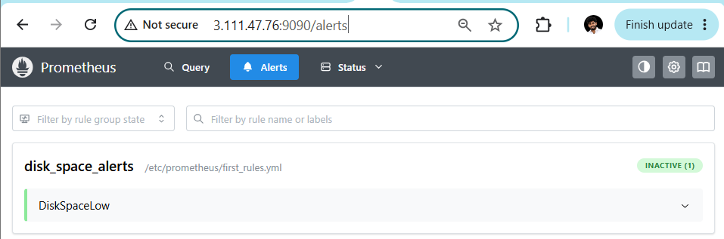

Challenge 9: Create a Custom Grafana Dashboard
We'll create a dashboard to monitor CPU usage, memory usage, disk usage, and target health using your existing Prometheus and Node Exporter.
Step 1: Open Grafana
Open Grafana.
Go to Dashboards → New → New dashboard → Add visualization.
Select your existing Prometheus data source.
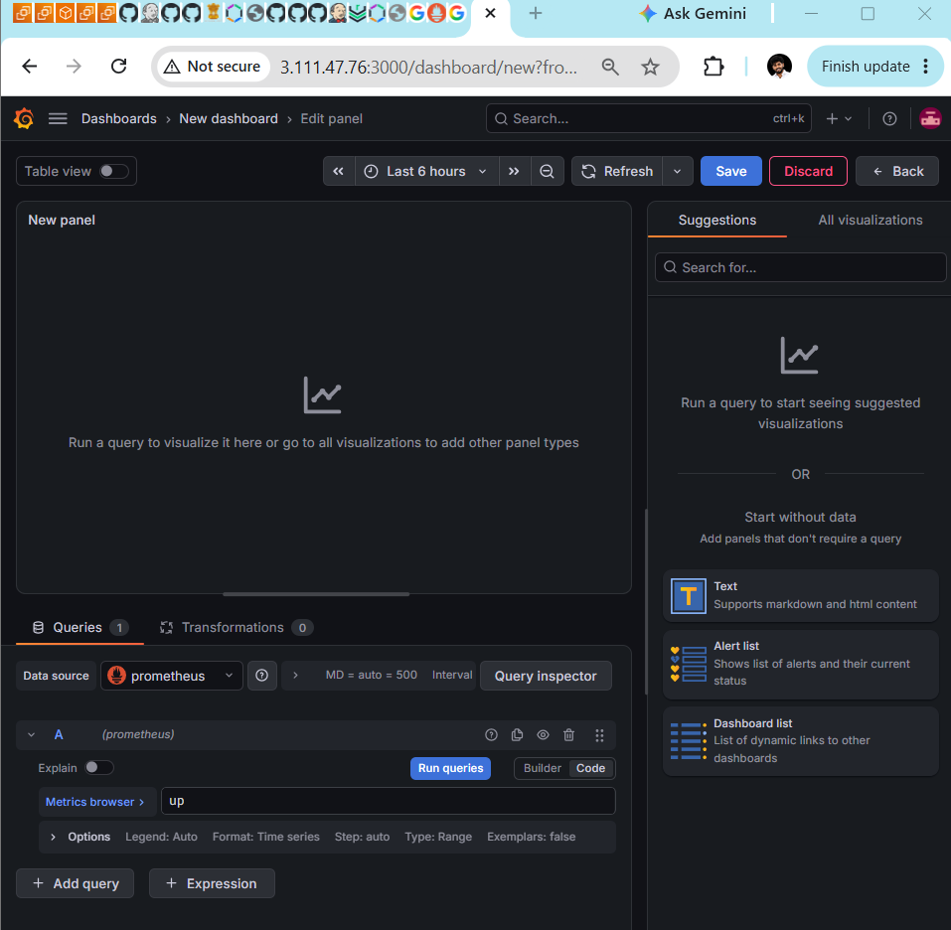
Step 2: Create a CPU usage panel
In the query editor, select code mode and enter:
100 * (1 - avg by (instance) (
rate(node_cpu_seconds_total{mode="idle"}[5m])
))
- Panel title: CPU Usage (%)
- Visualization: Time series
- Unit: Percent (0-100)
- Click Run queries if needed, then Apply.
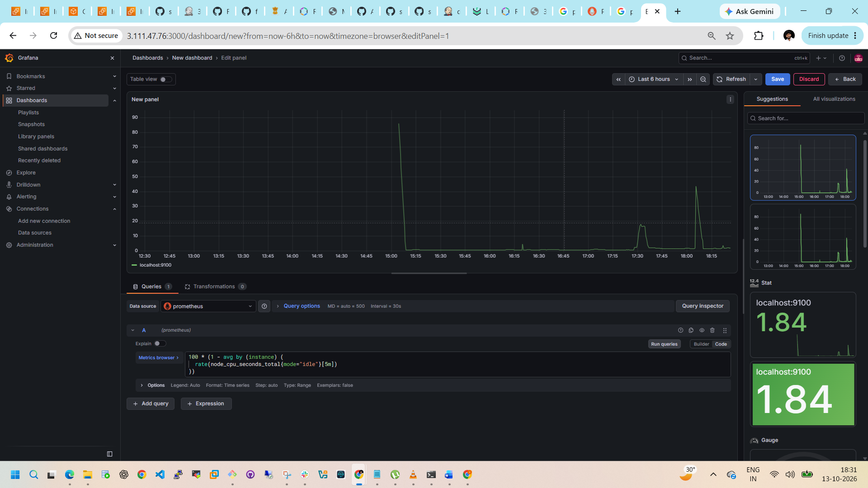
Step 3: Create a memory usage panel
Click Add → Visualization and use:
100 * (
1 -
node_memory_MemAvailable_bytes
/
node_memory_MemTotal_bytes
)
- Panel title: Memory Usage (%)
- Unit: Percent (0-100)
- Click Apply.
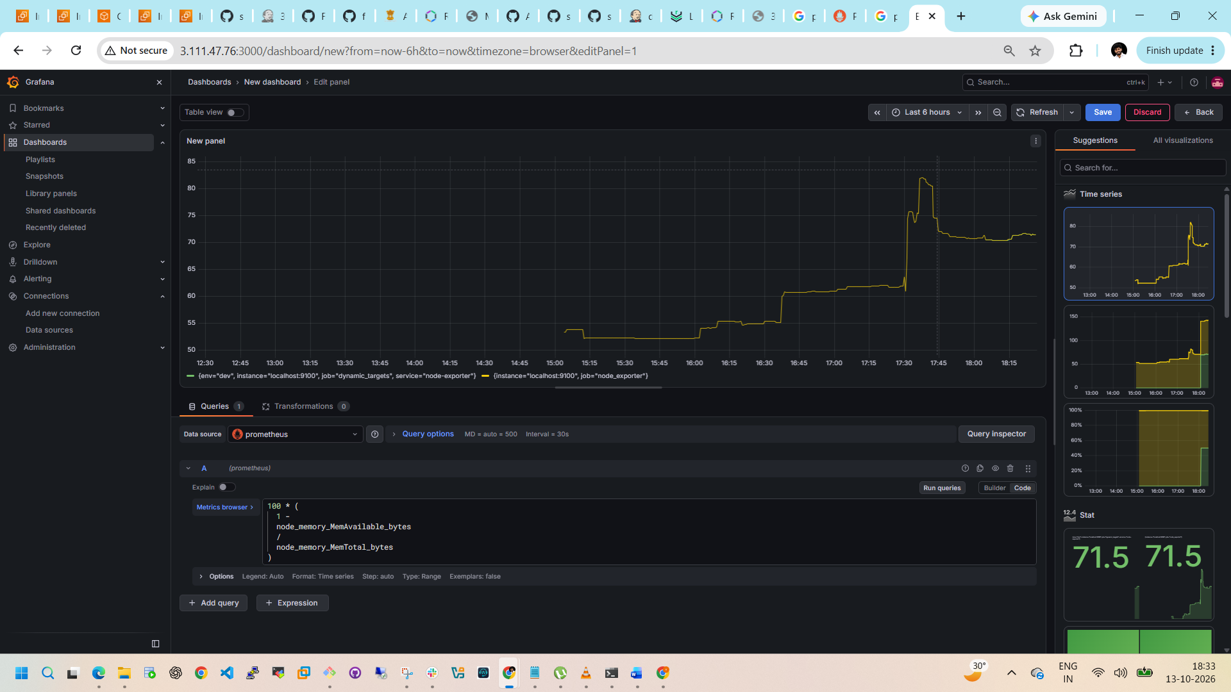
Step 4: Create a disk usage panel
Add another visualization and enter:
100 * (
1 -
node_filesystem_avail_bytes{
mountpoint="/",
fstype!~"tmpfs|overlay"
}
/
node_filesystem_size_bytes{
mountpoint="/",
fstype!~"tmpfs|overlay"
}
)
- Panel title: Root Disk Usage (%)
- Unit: Percent (0-100)
- Click Apply.
Step 5: Create a target health panel
Add one more visualization:
up
- Panel title: Prometheus Target Health
- Visualization: Stat
- Value 1 means UP; 0 means DOWN.
- Click Apply.
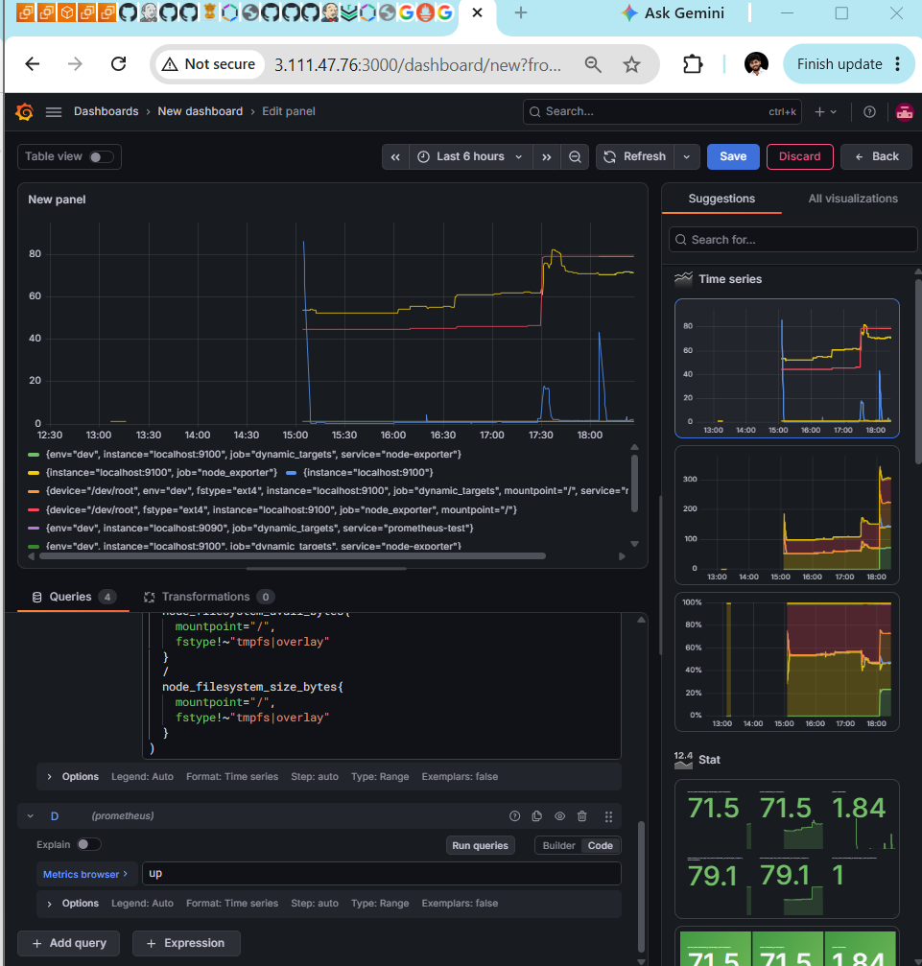
Step 6: Save the dashboard
- Click Save dashboard.
- Dashboard name: DevOps Monitoring Dashboard.
- Click Save to confirm.
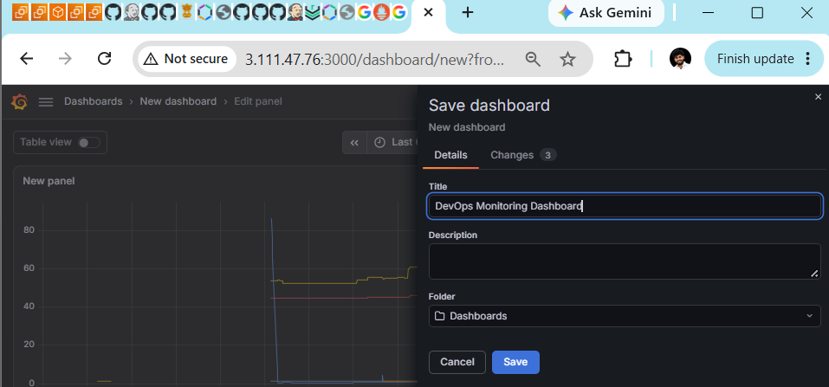
Step 7: Verify
Your dashboard should contain these four panels:
CPU Usage
CPU utilization over time
Memory Usage
Memory utilization
Disk Usage
Root filesystem utilization
Target Health
Exporter and Prometheus status
If any panel shows No data, check that your node_exporter target is UP on the Prometheus Targets page.
